**Topic:** The Great Theorem, Area of a Circle

**Notes on Topic:**

Around 225 BC, Archimedes released a treatise called *Measurement of a Circle*, the very first proposition gave insight into the area of a circle

Let’s examine what has been addressed regarding circles when Archimedes arrived on the scene

At the time, geometers would have known,

* The ratio of a circle’s circumference to its diameter is always a constant value (we now know this as pi)
* The ratio of a circle’s area to the square of its diameter is always a constant (this constant is known as *k* , where there is some relation between k and pi, we later find out that 4k = pi)

The final great proof required two preliminaries, the area of a regular polygon:

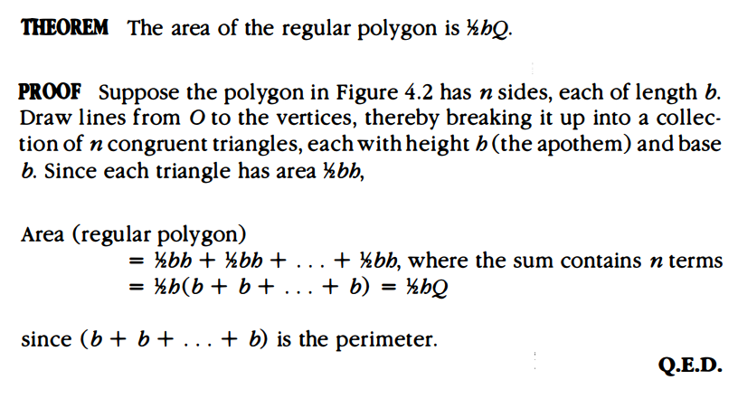

The second preliminary again involves inscribing regular polygons in a circle, using Eudoxus’ method of exhaustion. Given the regular n-gon inscribed, as n approaches infinity, the regular polygon area approaches the circles area.

The idea behind the method of exhaustion is that you can determine a preassigned area such that Area (circle) - Area (regular polygon) = (preassigned) Area. Even if the regular polygon requires hundreds of sides, this is immaterial, the fact that it *exists* is what this hinders on.

These are the two preliminaries; now consider, for any circle, we can find polygons that are inscribed and circumscribed about the circle whose areas are as close to the circle’s area “as we want” therefore establishing upper and lower bounds for the circle’s true area.

Archimedes’ approach is devious, unlike what we have seen thus far.

Archimedes used a clever approach for showing two things are equal. First one must conclude that two given quantities A, B must either be A < B , A > B, A = B. Archimedes ultimately wanted to show A = B. So first we conclude that A < B, then draw a contradiction, then we conclude A > B and draw a contradiction. Therefore forcing the quantities to be equal in value.

This is an indirect strategy that we may be familiar with now, but at the time this attack from the side approach was clever and cunning.

With this approach and these propositions behind him, Archimedes was then able to tackle the first proposition in *Measurement of a Circle*

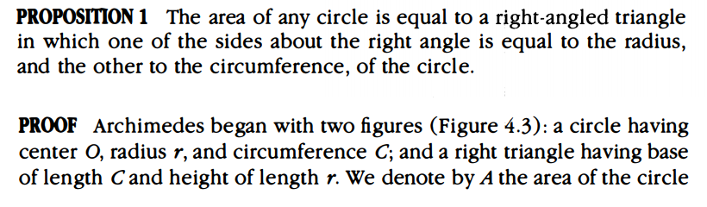

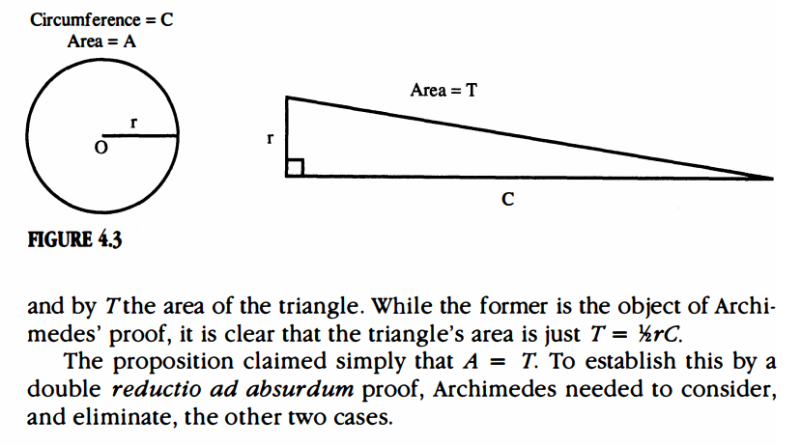

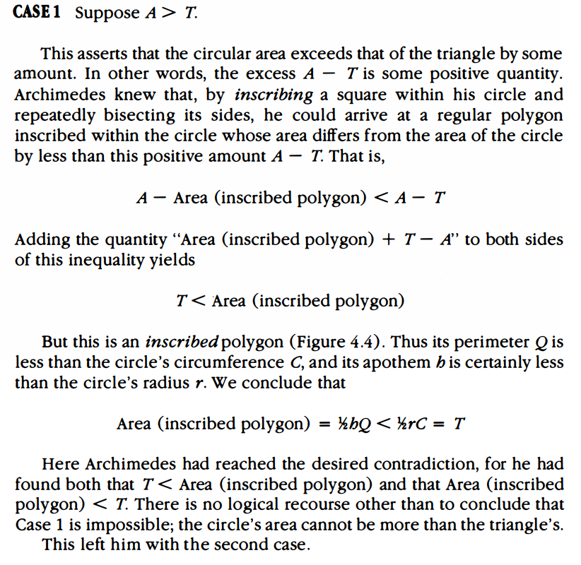

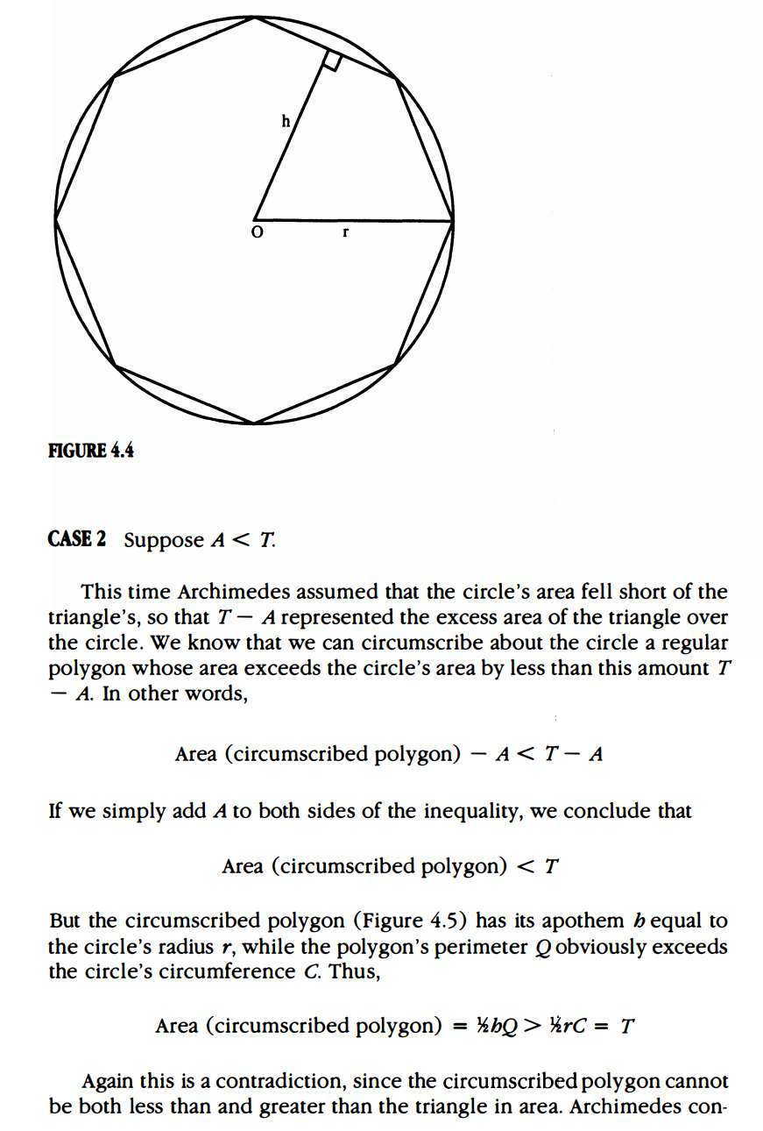

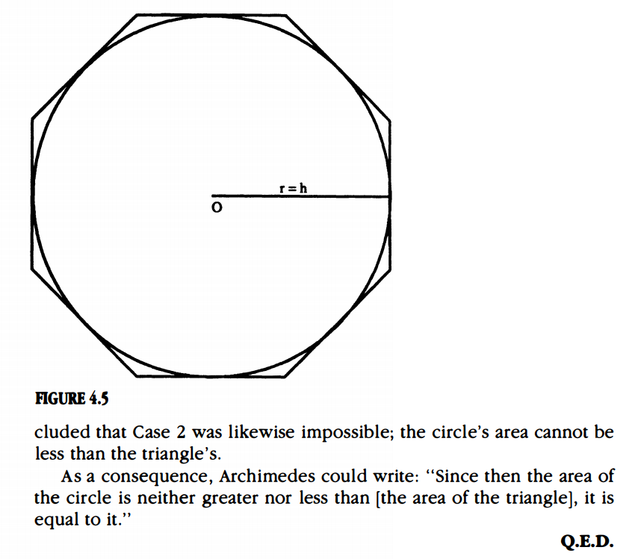

Another passage for Plutarch on the genius of Archimedes:

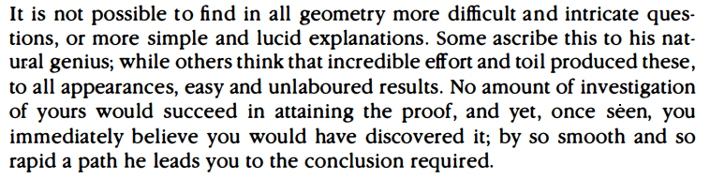

Archimedes specialty is taking the area of a sophisticated figure and relating it to a simpler one.

Archimedes had shown that A = ½ rC, therefore providing a link between the one dimensional circumference and two dimensional area. Since C = 2 * pi * r this implies that A=pi*r^2.

Archimedes consequently also proved one of Euclid’s propositions, diminishing a great proposition to merely a corollary of this theorem.

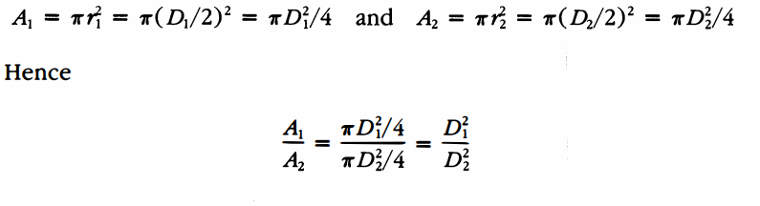

Looking back at a previous discussion, we can now establish a relationship between pi and the constant k. Given A = k * D^2 = k * (2r)^2 = 4kr^2, which implies pi = 4k.

Archimedes then established upper and lower bounds for the value of pi.

He again used the method of exhaustion using inscribed and circumscribed polygons but this time focusing on the perimeter and not the area of the figures.

Ultimately he drew the conclusion that $3\frac{10}{11}<π<3\frac{1}{7}$ which means he approximated that 3.140845 < $π$ < 3.142857, therefore establishing the first three digits of pi.

**Additional Suggested Reading**: JTG 97-98, Archimedes approach to approximating $π$

**Assignment:** Homework Problems 56, 58, 59, 60, 61